Cash In Interface Specification Low Level Design Document

**EIDIKOSYSTEMS INTEGRATORS**



Version: 1.0

Release Date:11 -08 -2020

|  |  |  |
| --- | --- | --- |
| Prepared By | Reviewed By | Approved By |
| EIDIKO |  |  |

Document Classification: CONFIDENTIAL

Contents

1 Introduction 5

1.1 General Description 5

2 Purpose 5

3 Scope 5

3.1 In Scope 5

4 Channels Involved 5

5 Interface Dependencies 6

5.1 External Dependencies 6

5.2 Internal Dependencies 6

6 Business Process Summary 7

6.1 Process Overview 7

Figure:1 Process flow Approach for Cash In Transfer. 7

6.1.1 Cash In Steps 7

7 IIB Implementation Process Flow 8

7.1 Cash In Successful Request Response Flow 8

7.1.1 Process Diagram 8

7.1.2 Process Flow Steps 8

7.2 Retry Process workflow 9

7.2.1 Process Flow Diagram 9

7.2.2 Process Flow steps 9

8 Interface Definitions 15

8.1 Request Message Definition 15

8.1.1 T24 Request Message Structure /Schema 15

8.1.2 T24 Request Message Details 15

8.1.3 T24 Sample Source Messages 16

8.1.4 Mobiquity Request Message Structure /Schema 17

8.1.5 Mobiquity Request Message Details 17

8.1.6 Mobiquity Sample Source Messages 18

8.1.7 Data Base Response Codes 18

8.2 Response Message Definition 19

8.2.1 Mobiquity Response Message Structure/Schema 19

8.2.2 Mobiquity Response Message Details 19

8.2.3 Mobiquity Sample Response Messages 20

8.2.4 T24 Response Message Details 20

8.2.5 T24 Sample Response Messages 21

9 Logging Mechanism 22

9.3 File Based Logging 26

9.3.1 Log4j 26

**Approval**

|  |  |  |  |  |
| --- | --- | --- | --- | --- |
| Project Role | Approver | Company | E-mail | Sign-Off Date |
| Delivery Manager |  | Eidiko |  |  |
|  |  |  |  |  |
|  |  |  |  |  |
|  |  |  |  |  |
|  |  |  |  |  |
|  |  |  |  |  |
|  |  |  |  |  |

**Revision History**

|  |  |  |  |
| --- | --- | --- | --- |
| Date | Description | Version | Author |
|  |  |  |  |
|  |  |  |  |
|  |  |  |  |
|  |  |  |  |
|  |  |  |  |
|  |  |  |  |

# Introduction

## General Description

This Interface Design document outlines the integration requirements for the Cash In ***(Request and Response)***interface used as banking operations. It summarizes the business processes, which use this interface. It also covers error handling and exception scenarios.

# Purpose

The purpose of this document is to capture events that trigger the interface, main steps within the interface and the integration architecture. This document is intended for use by the developers of the applications identified, the integration development team, and by the test organizations responsible for the testing of these applications.

# Scope

## In Scope

This document focuses on outlining the interface design for the Cash In***(Request and Response)***interface. Central to this document are the following:

* Overview of the business process that drives the need for the interface
* Proposed integration approach
* Trigger events and business dependencies on this interface
* Sequence /Flow Chart diagram of the interface
* Data mapping between the source and the target
* Error handling and exception scenarios
* Validation and backup requirements

# Channels Involved

The following table lists Cash In channels

|  |  |
| --- | --- |
| **Item #** | **Channel Name** |
| 1 | Branch |

# Interface Dependencies

## External Dependencies

The following table lists interface specific External requirements.

|  |  |
| --- | --- |
| **Item #** | **External Requirements** |
| 1 | ORADSN Data Base |
| 2 | Core Banking System |

## Internal Dependencies

The following table lists interface specific internal requirements.

|  |  |
| --- | --- |
| **Item #** | **Internal Requirements** |
| 1 | HTTP Router Interface |
| 2 | HTTP Retry Interface |
| 3 | DB Logging App |
|  |  |

# Business Process Summary

## Process Overview

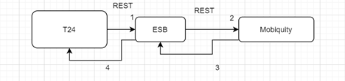

### Figure:1 Process flow Approach for Cash In Transfer.

### Cash In Steps

|  |  |
| --- | --- |
| **S. No** | **Activities** |
| 1 | ESB receives the request from channel(T24). |
| 2 | Request channel is the http request accepts the request from the channel |
| 3 | ESB frames the Request According to the Mobiquity requires and send to the Mobiquity. |
| 4 | Mobiquity will Respond back to the ESB with Response |
| 5 | The same Mobiquity Response, ESB will send back to the T24 |
| 6 | On Successful calls of Mobiquity and T24 Request and Response will be placed in the RAW_LOG_SB_REQ to log the request in Data Base (RAW_AUDIT_LOGGING |
| 7 | On Unsuccessful calls of Mobiquity and T24 Request and Response will be placed in the ERROR_LOG_SB_REQ to log the request in Data Base (ERR_AUDIT_LOGGING |

# IIB Implementation Process Flow

## Cash In Successful Request Response Flow

### Process Diagram

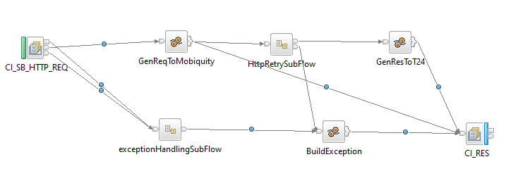

**Figure:2 Cash In Flow**

### Process Flow Steps

|  |  |
| --- | --- |
| **S. No** | **Activities** |
| 1. | ESB receives the request from the channel(T24) using the HTTP Router Application based on proessingcode trigs the Business Application (CASHIN) using Business Queue (CI_SB_HTTP_REQ) i.e Request from channel. |
| 2 | Initial request and response are logged in the RAW_LOG_SB_REQ and is insert in Data Base (RAW_AUDIT_LOGGING) |
| 3 | After logging of request and response ESB frames the Request to backend server i.e Mobiquity server |
| 4 | After Framing the Mobiquity Request is logged in RAW_LOG_SB_REQ and is insert in Data Base (RAW_AUDIT_LOGGING) |
| 5 | If the Mobiquity call is successful, then JSON response is generate. |
| 6 | Mobiquity Response in JSON Format is logged in RAW_LOG_SB_REQ |
| 7 | After ever the Response is generated by Mobiquity call same response is sending back to Channel with the help of HTTP Router Application. Here ESB frames the Channel Response (T24 Response) |
| 8 | T24 Response is logged in RAW_LOG_SB_REQ and is insert in Data Base (RAW_AUDIT_LOGGING) |
| 9 | On Unsuccessfull calls of Mobiquity and T24 Request and Response will be placed in the ERROR_LOG_SB_REQ to log the request in Data Base (ERR_AUDIT_LOGGING) |

## Retry Process workflow

### Process Flow Diagram

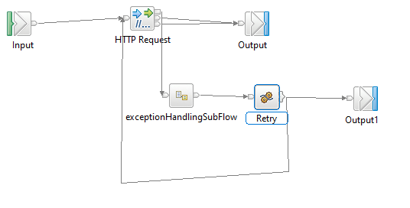

**Figure:3 HTTP Retry for Cash In**

### Process Flow steps

|  |  |
| --- | --- |
| **S. No** | **Activities** |
| 1 | HTTP Retry call is used to call the backend service for multiple times |
| 2 | On Successful call of backend service, response will be generated and send back to Business Application For further process |
| 3 | On Unsuccessful call of backend service it Retry for 3 times and sends error message to Business Application for further Process |

**7.3 Raw_Audit Process Flow:**

**7.3.1 Process Flow Diagram:**

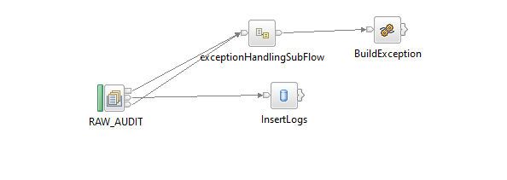

**Figure:4 Raw_Audit_Logging Flow**

**7.3.2 Process Flow Steps:**

|  |  |
| --- | --- |
| **S. No** | **Activities** |
|  | The RAW_AUDIT locks the input Request and Response |
|  | After the query is executed the record is inserted into the Data Base. |
|  | Final Response is inserted into the Data Base and then Response is logged into the RAW_LOG_SB_REQ. |

**7.4 HTTP Router Process Flow**

**7.4.1 Incoming Router Process Flow Diagram:**

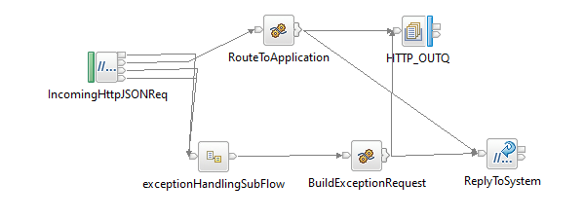

**Figure:5 Incoming Router Flow**

**7.4.2 Process Flow Steps:**

|  |  |
| --- | --- |
| **S. No** | IIB receives the request from channel. |
|  | ESB receives the request from channel. |
|  | Request channel is the http request accepts the request from the channel |
|  | The request message is placed in the RAW_LOG_SB_REQ to log the request in Data Base (RAW_AUDIT_LOGGING) |
|  | According to the Channel Request message fields such as channel and processing code it picks the queue name of the business flow from STWB_ESB_TRAN_DETAILS table and propagates it to the business flow. |
|  | It validates the processingCode, Channel and domain of input from STWB_ESB_TRAN_DETAILS if it fails to validate the error response is logged in the logs and in Data Base (ERROR_AUDIT_LOG) |
|  | After the validation Request message is passed through ESB. If the queue name presents in MQ manager the ESB business flow triggers otherwise the error response is sent to the front end as Unable to open queue. |
|  | If it is success or failure response will store them in RAW_AUDIT_LOG table or ERROR_AUDIT_LOG and logging into log file. |
|  | The request from channel is sent to ESB CashOut Flow |

**7.4.3 Steward Bank ESB Transaction Details**

**Table Name: STWB_ESB_TRAN_DETAILS**

|  |  |  |  |  |  |  |
| --- | --- | --- | --- | --- | --- | --- |
| **Item #** | **DB Field Name** | **Field Description** | **Data Type** | **Length** | **Mandatory(Yes/No)** | **Comments** |
| 1 | PROC_CODE | Processing Code | Varchar | 20 | Y | From input request |
| 2 | REQ_QUEUE | TCPIP Request Queue | Varchar | 20 | N | This Request Queue Name field is used for ISO Related Application |
| 3 | RES_QUEUE | TCPIP Response Queue | Varchar | 20 | N | This Response Queue Name field is used for ISO Related Application |
| 4 | HTTP_REQ | HTTP Request Queue | Varchar | 20 | Y | This Request Queue Name field is used for REST Related Application |
| 5 | HTTP_RES | HTTP Response Queue | Varchar | 20 | Y | This Response Queue Name field is used for REST Related Application |
| 6 | CHANNEL | Channel | Varchar | 20 | Y | Channel Name |
| 7 | MSGDOMAIN | Message Domain | Varchar | 20 | Y | Request Message Format |

**7.4.4 Outgoing Router Process Flow Diagram**

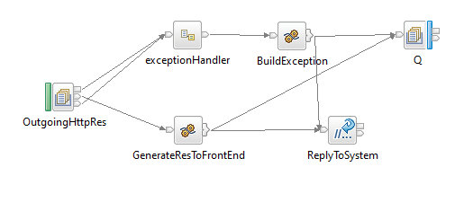

**Figure:6 Outgoing Router Flow**

**7.4.5 Process Flow Steps:**

|  |  |
| --- | --- |
| **S. No** | **Activities** |
|  | The OutgoingHttpRes brings the Channel Response |
|  | Channel Response will be logged in RAW_LOG_SB_REQ and insert in Data Base. |
|  | Finally Channel Response will be send to the Front End. |

**7.5 Error_Audit Process Flow**

**7.5.1 Process Flow Diagram:**

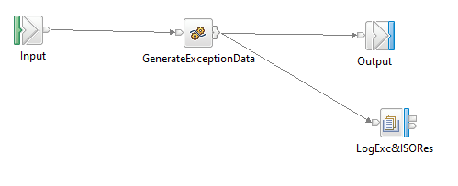

**Figure:7** **Exception Subflow**

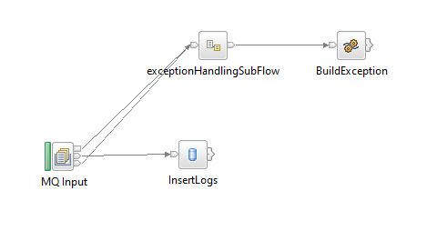

**Figure:8** **Error_Audit_Logging Flow**

**7.5.2 Process Flow Steps:**

|  |  |
| --- | --- |
| **S. No** | **Activities** |
|  | The ERROR_AUDIT_Q locks the input Request. |
|  | After the query is executed the record is inserted into the Data Base. |
|  | Final Response is inserted into the Data Base and then Response is logged into the ERR_LOG_SB_REQ. |

# Interface Definitions

## Request Message Definition

### T24 Request Message Structure /Schema

**Request Type:** HTTP

**Request Format:** JSON

**Request URL:** <http://IPAddress:Port/v1/stewardBank/>

### 8.1.2 T24 Request Message Details

|  |  |  |  |  |
| --- | --- | --- | --- | --- |
| **Item #** | **Tag Name/ Field Name** | **Data Type** | **Mandatory(Yes/No)** | **Comments** |
| 1 | CashIn |  | Y | Root Tag |
| 2 | Header |  | Y | Header Tag |
| 3 | Channel | String | Y | Channel Name |
| 4 | ProcessingCode | String | Y | Processing Code |
| 7 | Body | String | Y | Body Tag |
| 8 | ServiceCode | String | Y | Service Code |
| 9 | BearerCode | String | Y | Bearer Code |
| 10 | TransactionAmount | Decimal | Y | Amount to transfer |
| 11 | Currency | String | Y | Currency |
| 12 | ExternalReferenceId | String | Y | External Reference Id |
| 13 | Remarks | String | Y | Remarks |
| 14 | TransactionMode | String | Y | Mode of Transaction |
| 15 | Initiator | String | Y | Initiator |
| 16 | Language | String | Y | Language |
| 17 | Transactor |  | Y | Transactor Tag |
| 18 | IdType | String | Y | Type of Id |
| 19 | IdValue | String | Y | Value of Id |
| 20 | Productid | String | Y | Id of Product |
| 21 | mpin | String | Y | MPIN Value |
| 22 | tpin | String | Y | TPIN Value |
| 23 | Receiver |  | Y | Receiver Tag |
| 24 | IdType | String | Y | Type of Id |
| 25 | IdValue | String | Y | Value of Id |
| 26 | Productid | String | Y | Id of Product |

### 8.1.3 T24 Sample Source Messages

|  |
| --- |
| {     "CashIn":{        "header":{           "channel":"Branch",           "processingCode":"030000"        },        "body":{           "serviceCode":"CASHIN",           "bearerCode":"USSD",           "transactionAmount":"1",           "currency":"101",           "externalReferenceId":"",           "remarks":"CashIn",           "transactionMode":"transactionMode",           "initiator":"transactor",           "language":"en",           "transactor":{              "idType":"mobileNumber",              "idValue":"783759396",              "productId":"12",              "mpin":"4827",              "tpin":"4827"           },           "receiver":{              "idType":"mobileNumber",              "idValue":"774349669",              "productId":"12"           }        }     }  } |

### 8.1.4 Mobiquity Request Message Structure /Schema

**Request Type:** HTTP

**Request Format:** JSON

**Request URL:** <http://IPAddress:Port/jigsaw/serviceRequest/CASHIN>

### 8.1.5 Mobiquity Request Message Details

|  |  |  |  |  |
| --- | --- | --- | --- | --- |
| **Item #** | **Tag Name/ Field Name** | **Data Type** | **Mandatory(Yes/No)** | **Comments** |
| 8 | ServiceCode | String | Y | Service Code |
| 9 | BearerCode | String | Y | Bearer Code |
| 10 | TransactionAmount | Decimal | Y | Amount to transfer |
| 11 | Currency | String | Y | Currency |
| 12 | ExternalReferenceId | String | Y | External Reference Id |
| 13 | Remarks | String | Y | Remarks |
| 14 | TransactionMode | String | Y | Mode of Transaction |
| 15 | Initiator | String | Y | Initiator |
| 16 | Language | String | Y | Language |
| 17 | Transactor |  | Y | Transactor Tag |
| 18 | IdType | String | Y | Type of Id |
| 19 | IdValue | String | Y | Value of Id |
| 20 | Productid | String | Y | Id of Product |
| 21 | mpin | String | Y | MPIN Value |
| 22 | tpin | String | Y | TPIN Value |
| 23 | Receiver |  | Y | Receiver Tag |
| 24 | IdType | String | Y | Type of Id |
| 25 | IdValue | String | Y | Value of Id |
| 26 | Productid | String | Y | Id of Product |

### 8.1.6 Mobiquity Sample Source Messages

|  |
| --- |
| {           "serviceCode":"CASHIN",           "bearerCode":"USSD",           "transactionAmount":"1",           "currency":"101",           "externalReferenceId":"",           "remarks":"CashIn",           "transactionMode":"transactionMode",           "initiator":"transactor",           "language":"en",           "transactor":{              "idType":"mobileNumber",              "idValue":"783759396",              "productId":"12",              "mpin":"4827",              "tpin":"4827"           },           "receiver":{              "idType":"mobileNumber",              "idValue":"774349669",              "productId":"12"           }        } |

### 8.1.7 Data Base Error Response Codes

001 = "Fatal Exception";

002 = " Recoverable Exception ";

003 = "Configuration Exception";

004 = "Security Exception";

005 = "Parser Exception";

006 = "Conversion Exception";

007 = "Data Base Exception";

008 = "User Exception";

009 = "Cast Exception";

010 = "Message Exception";

011 = "SQL Exception";

012 = "Socket Exception";

013 = "Socket Timeout Exception";

014 = "Unknown Exception";

015 = "Failure";

## Response Message Definition

### Mobiquity Response Message Structure/Schema

**Response Type:** JSON

### Mobiquity Response Message Details

|  |  |  |  |  |
| --- | --- | --- | --- | --- |
| **Item #** | **Tag Name/Field Name** | **Data Type** | **Mandatory(Yes/No)** | **Comments** |
| 1 | ReceiverLastName | String | Y | Receiver Last Name |
| 2 | senderMobileNumber | String | Y | Sender Mobile Number |
| 3 | ServiceRequestId | String | Y | Service Request Id |
| 4 | MfsTenantId | String | Y | Mfs Tenant Id |
| 5 | SenderFirstName | String | Y | Sender First Name |
| 6 | ServiceFlow | String | Y | Service Flow |
| 7 | TransactionId | String | Y | Transaction Id |
| 8 | Message | String | Y | Message |
| 9 | originalServiceRequestId | String | Y | Request Id of Original Service |
| 10 | TxnStatus | String | Y | Status of Transaction |
| 11 | receiverMobileNumber | String | Y | Mobile Number of Receiver |
| 12 | ReceiverFirstName | String | Y | Receiver Last Name |
| 13 | SenderLastName | String | Y | Sender Last Name |
| 14 | Remarks | String | Y | Remarks |
| 15 | Status | String | Y | Status |

### 8.2.3 Mobiquity Sample Response Messages

|  |
| --- |
| {              "receiverLastName": "Vambe",              "senderMobileNumber": "783759396",              "serviceRequestId": "df1497b5-031f-4436-88dc-1ba960044833",              "mfsTenantId": "mfsPrimaryTenant",              "senderFirstName": "DAYTAL INVEST",              "serviceFlow": "CASHIN",              "message": "Cash In transaction of RTGS$ 1 has been successfully completed between the sender: 69420 and receiver: 774349669. Txn ID: CI200803.0649.003153. New balance: RTGS$ 72.71",              "transactionId": "CI200803.0649.003153",              "originalServiceRequestId": "df1497b5-031f-4436-88dc-1ba960044833",              "txnStatus": "TS",              "receiverMobileNumber": "774349669",              "receiverFirstName": "Tafara",              "senderLastName": "VHENEKA",              "remarks": "CashIn",              "status": "SUCCEEDED"          } |

### 8.2.4 T24 Response Message Details

|  |  |  |  |  |
| --- | --- | --- | --- | --- |
| **Item #** | **Tag Name/Field Name** | **Data Type** | **Mandatory(Yes/No)** | **Comments** |
| 1 | CashIn | String | Y | Root Tag |
| 2 | Header | String | Y | Header Tag |
| 3 | channel | String | Y | Channel Name |
| 4 | ProcessingCode | String | Y | Processing Code |
| 5 | Status | String | Y | Status |
| 6 | ResponseCode | String | Y | Response Code |
| 7 | Body | String | Y | Body Tag |
| 8 | ReceiverLastName | String | Y | Receiver Last Name |
| 9 | senderMobileNumber | String | Y | Sender Mobile Number |
| 10 | ServiceRequestId | String | Y | Service Request Id |
| 11 | MfsTenantId | String | Y | Mfs Tenant Id |
| 12 | SenderFirstName | String | Y | Sender First Name |
| 13 | ServiceFlow | String | Y | Service Flow |
| 14 | TransactionId | String | Y | Transaction Id |
| 15 | Message | String | Y | Message |
| 15 | originalServiceRequestId | String | Y | Request Id of Original Service |
| 16 | TxnStatus | String | Y | Status of Transaction |
| 17 | receiverMobileNumber | String | Y | Mobile Number of Receiver |
| 18 | ReceiverFirstName | String | Y | Receiver Last Name |
| 19 | SenderLastName | String | Y | Sender Last Name |
| 20 | Remarks | String | Y | Remarks |
| 21 | Status | String | Y | Status |

### 8.2.5 T24 Sample Response Messages

|  |
| --- |
| {      "CashIn": {          "header": {              "channel": "Branch",              "processingCode": "030000",              "status": "SUCCESS",              "responseCode": "200"          },          "body": {              "receiverLastName": "Vambe",              "senderMobileNumber": "783759396",              "serviceRequestId": "df1497b5-031f-4436-88dc-1ba960044833",              "mfsTenantId": "mfsPrimaryTenant",              "senderFirstName": "DAYTAL INVEST",              "serviceFlow": "CASHIN",              "message": "Cash In transaction of RTGS$ 1 has been successfully completed between the sender: 69420 and receiver: 774349669. Txn ID: CI200803.0649.003153. New balance: RTGS$ 72.71",              "transactionId": "CI200803.0649.003153",              "originalServiceRequestId": "df1497b5-031f-4436-88dc-1ba960044833",              "txnStatus": "TS",              "receiverMobileNumber": "774349669",              "receiverFirstName": "Tafara",              "senderLastName": "VHENEKA",              "remarks": "CashIn",              "status": "SUCCEEDED"          }      }  } |

# Logging Mechanism

**9.1 Insert into Raw_Audit_Table**

**Table Name: RAW_AUDIT_TABLE**

|  |  |  |  |  |  |  |
| --- | --- | --- | --- | --- | --- | --- |
| **Item #** | **DB Field Name** | **Field Description** | **Data Type** | **Length** | **Mandatory(Yes/No)** | **Comments** |
| 1 | MSGID | MessageID | Varchar | 100 | Y | From input request |
| 2 | LOGGING_TIME | Logging Time | TimeStamp | 6 | Y | Name |
| 3 | MESSAGE | Message(Request/Response) | Clob | - | Y | Request from channel |
| 4 | MESSAGETYPE | Type of Message(Request/Response) | Varchar | 100 | Y | Type of message either Request or Response |
| 5 | APPNAME | Application Name | Varchar | 100 | Y | Name of the Application |
| 6 | BROKER | Broker Name | Varchar | 100 | Y | Broker Name |
| 7 | TIME_LOCAL_TRANSACTION | Transaction Time | Varchar | 20 | Y | Time of the Transaction |
| 8 | DATE_LOCAL_TRANSACTION | Transaction Date | Varchar | 20 | Y | Date of the Transaction |
| 9 | RETRIEVAL_REFERENCE_NUMBER | Retrieval Reference Number | Varchar | 20 | Y |  |

**9.2 Insert into Error_Audit_Table**

**Table Name: ERROR_AUDIT_TABLE**

|  |  |  |  |  |  |  |
| --- | --- | --- | --- | --- | --- | --- |
| **Item #** | **DB Field Name** | **Field Description** | **Data Type** | **Length** | **Mandatory(Yes/No)** | **Comments** |
| 1 | MSGID | MessageID | Varchar | 50 | Y | From input request |
| 2 | LOGGING_TIME | Application Name | Timestamp | 50 | Y | Time of the logging |
| 3 | MESSAGE | Message Type(Request/Response) | Clob | 50 | Y | Request of the Message |
| 4 | MESSAGETYPE | Message Type | Varchar | 50 | Y | Type of message either Request or Response |
| 5 | APPNAME | Application Name | Varchar | 4000 | Y | Name of the Application |
| 6 | BROKER | Broker Name | Varchar | - | Y | Name of the Broker |
| 7 | ERRORDESCRIPTION | Exception | Clob | 4000 | Y | Exception Information |
| 8 | TIME_LOCAL_TRANSACTION | Transaction Time | Varchar | 20 | Y | Time of the Transaction |
| 9 | DATE_LOCAL_TRANSACTION | Transaction Date | Varchar | 20 | Y | Date of the Transaction |
| 9 | RETRIEVAL_REFERENCE_NUMBER | Retrieval Reference Number | Varchar | 20 | Y | Retrieval Reference Number |
| 10 | BORKER_ERROR_CODE | Broker Error Code | Varchar |  | Y | Error code generate by Broker |
| 11 | USER_DEFINE_ERROR_CODE | User Defined Error Code | Varchar |  | Y | User Defined Code |

## 9.3 File Based Logging

### 9.3.1 Log4j

As part of auditing the request we have to use Log4j mechanism in the application to log the request in the file.

File Path: To be specified, while deploying the application